Project: Interdepartmental Network Design for Sales and Marketing using Cisco Packet Tracer

Project Overview
The purpose of this project is to design and implement a network in Cisco Packet Tracer to enable communication between Sales and Marketing departments in a organisation . The network will be properly segmented configured with appropriate IP addresses, and connectivity will be tested to ensure successful communication across the two departments .

Project Requirements :
- Each department should have at least 2 Pcs
- Appropriate number of switches and routers should be used in the network
- Using the given address block 192.168.40.0/24 , all interfaces should be configured with appropriate IP addresses , subnet mask and gateway
- All devices in the network should be connected using appropriate cables
- Ensure and Test connectivity between Sales and Marketing departments - PCs in Sales should be able to ping PCs in the Marketing department.

Subnet Plan for the 192.168.40.0/24 block
We will use a /29 , this is because the requirements state that at least two Pcs needed, and a /29 provides us with 6 usable addresses and 8 total addresses . This means if or when more devices need to be added, they can be easily added without us having to redo the subnet plan.

192.168.40.0/29
Name of network | Available hosts | Subnet Mask | Network Address | Address Range | Broadcast Address
Marketing | 6 | 255.255.255.248 | 192.168.40.0 | 192.168.40.1-192.168.40.6 | 192.168.40.7
Sales | 6 | 255.255.255.248 | 192.168.40.8 | 192.168.40.9-192.168.40.14 | 192.168.40.15

Structure
Devices , Cabling Interfaces and Network Topology
Devices
Router | Switch | End Devices
2911 (1x) | 2960 (2x) | PC-PT (4x)

Cabling
Router to Marketing Switch : Gigabit Ethernet 0/0 to Gigabit Ethernet 0/1
Router to Sales Switch: Gigabit Ethernet 0/1 to Gigabit Ethernet 0/1
Marketing switch to end devices: Fast Ethernet 0/1 to Fast Ethernet 0, and Fast Ethernet 0/2 to another Fast ethernet 0
Sales Switch to end devices: : Fast Ethernet 0/1 to Fast Ethernet 0, and Fast Ethernet 0/2 to another Fast ethernet 0

Topology
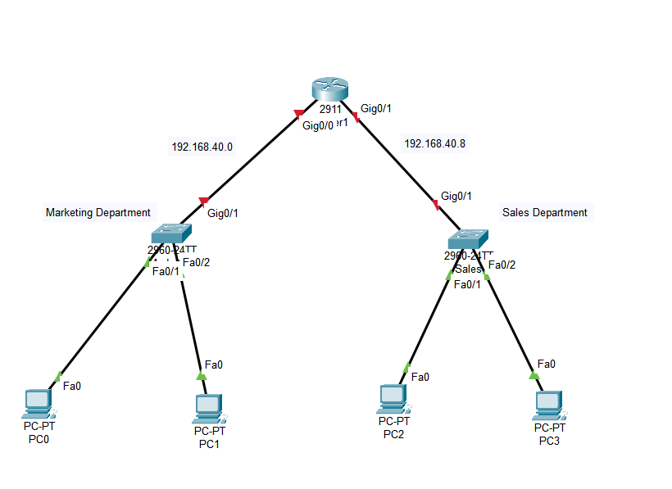

Configurations
Configuring Router interfaces
Marketing
Router>en
Router#config t
Enter configuration commands, one per line. End with CNTL/Z.
Router(config)#int gig0/0
Router(config-if)#ip address 192.168.40.1 255.255.255.248
Router(config-if)#no sh

Sales
Router(config-if)#int gig 0/1
Router(config-if)#ip address 192.168.40.9 255.255.255.248
Router(config-if)#no sh

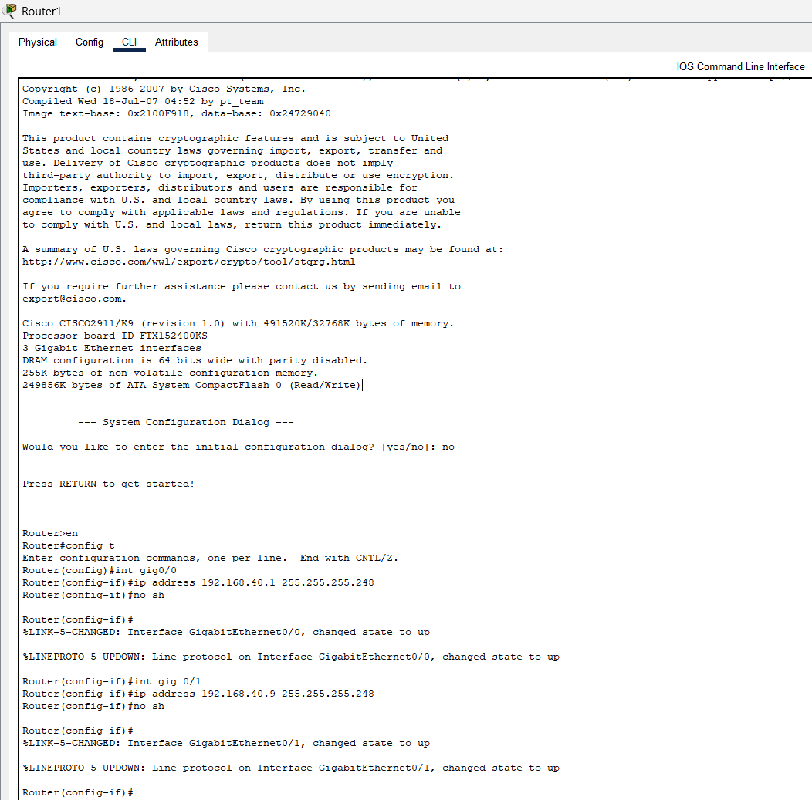

Assigning Static IP addresses to Marketing and Sales end devices
Marketing
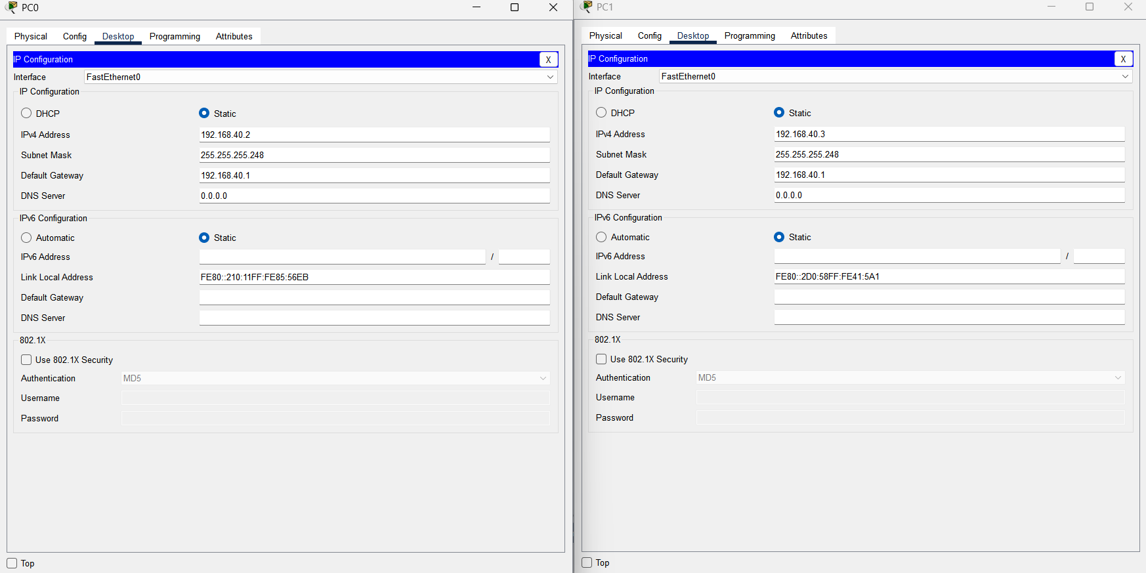

Sales
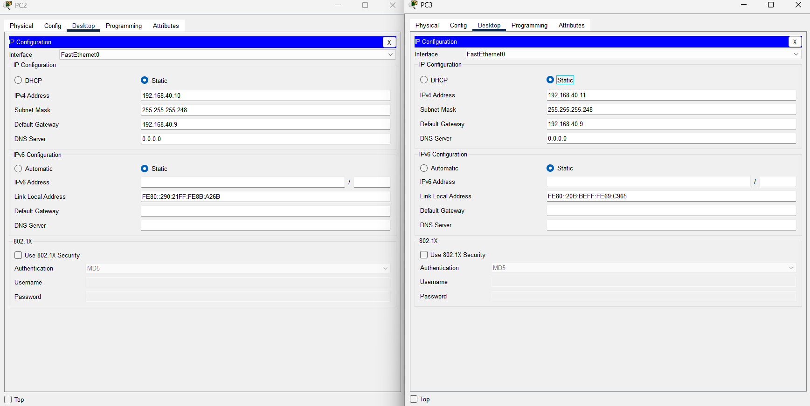

Connectivity
Test connectivity within departments
Marketing
Ping 192.168.40.2
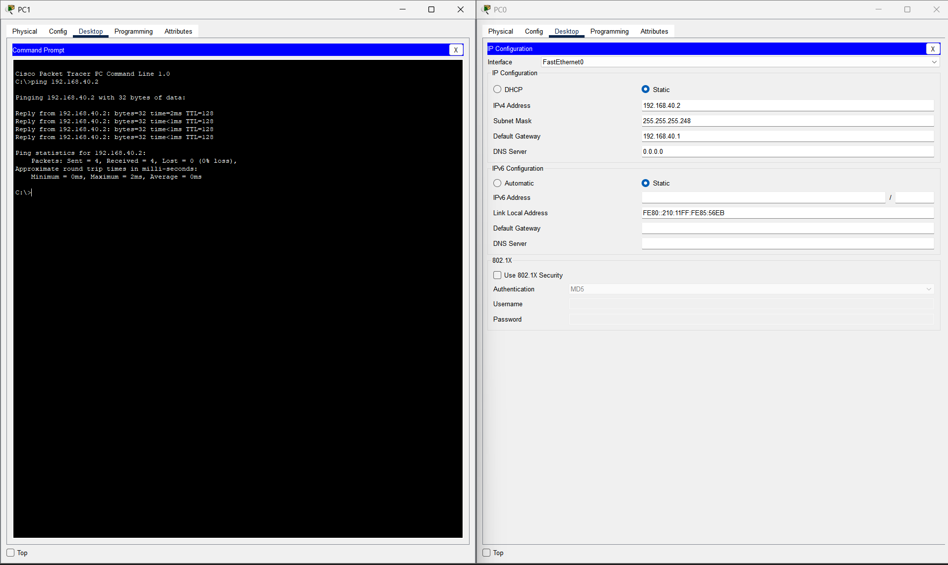

Sales
Ping 192.168.40.10
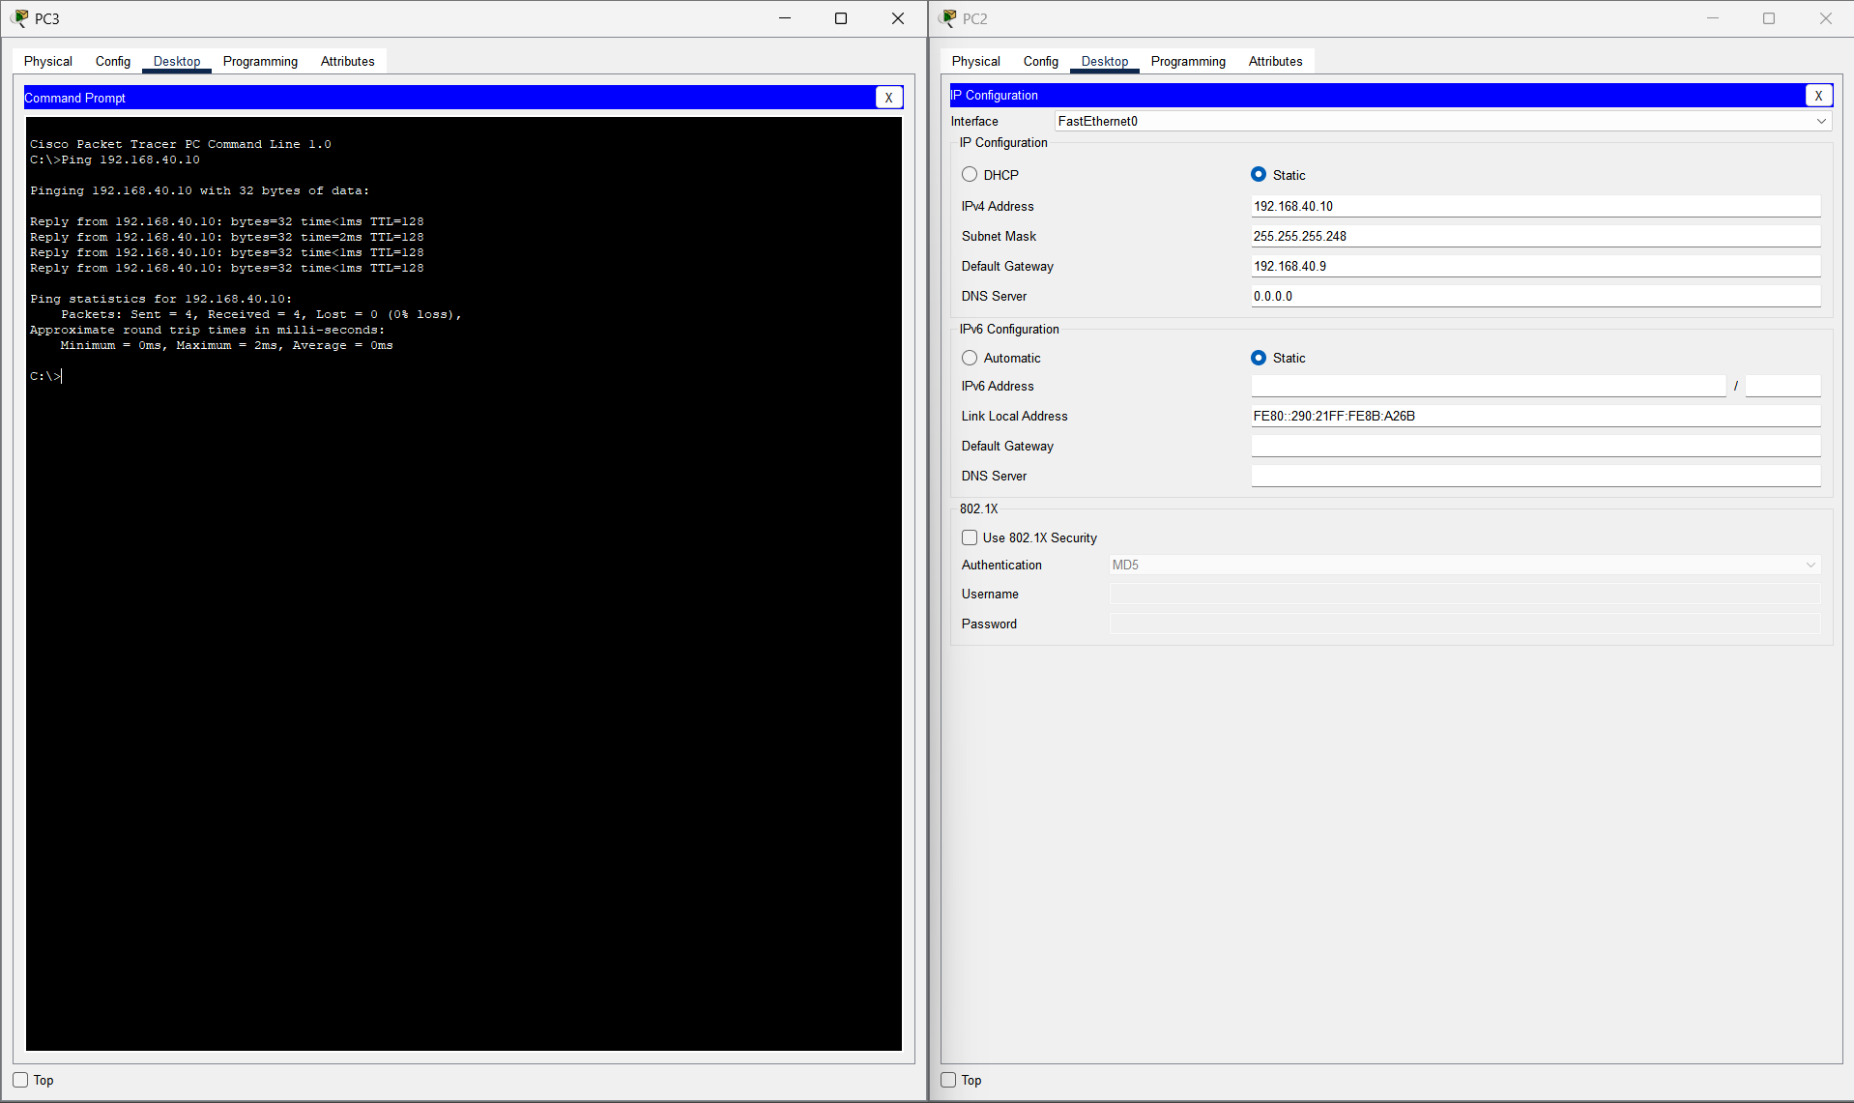

Testing Connectivity Between Sales and Marketing
Ping 192.168.40.11 on the marketing Pc
Ping 192.168.40.2 on the Sales Pc
